NAME : Namala Ushodaya
USN : 23BTRCL225
ID : HCLTFP2298165
BRANCH : AIML
BATCH : 2027
CLG : Jain University

SECTION A: ADVANCED SQL || Maximum Marks: 20
Question 1: Database Design and Advanced Queries (8 Marks)
a)
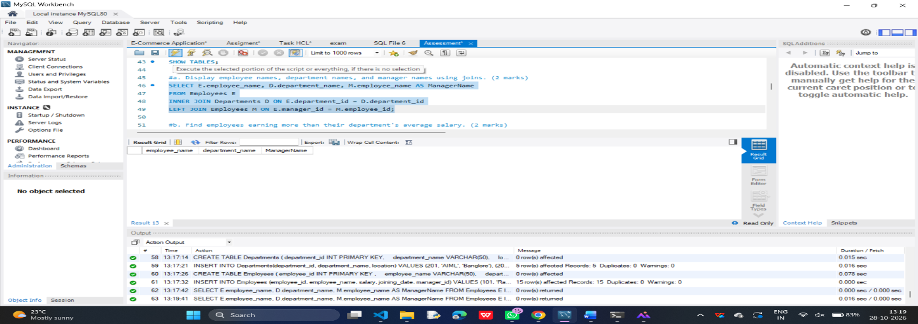
b)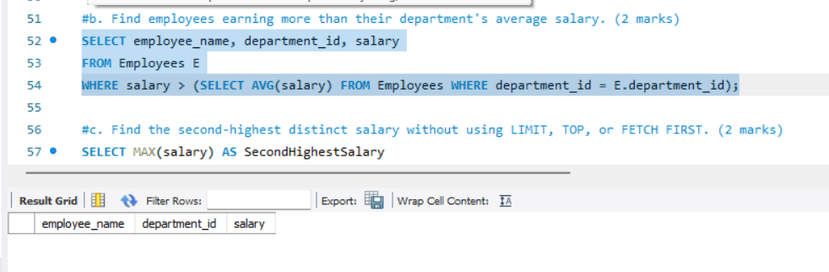c)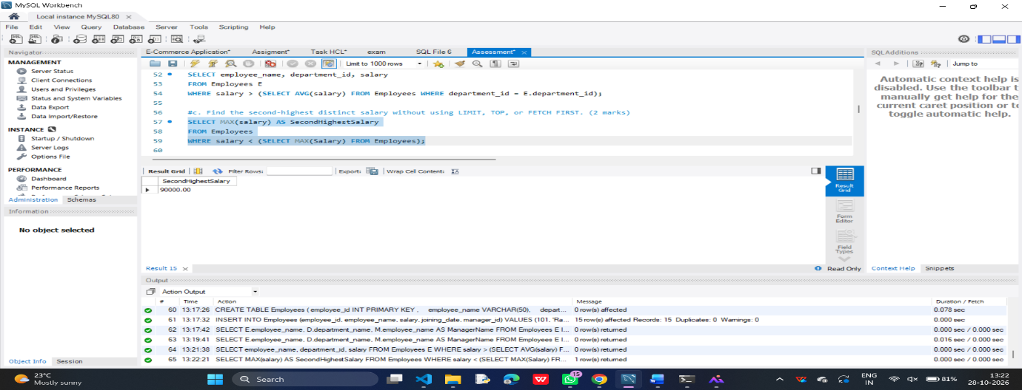

d)
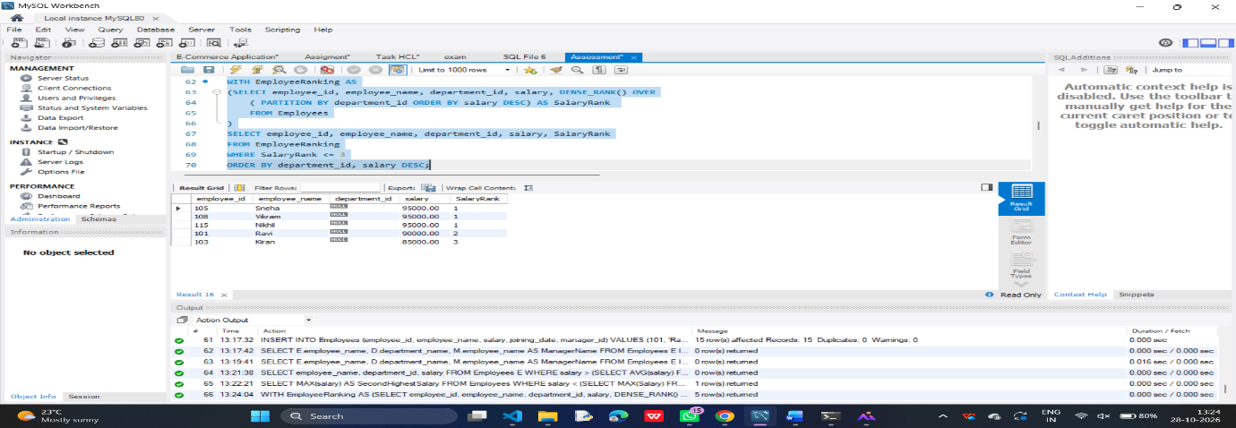

Question 2: Sales Analytics and Query Optimization (6 Marks)
a)
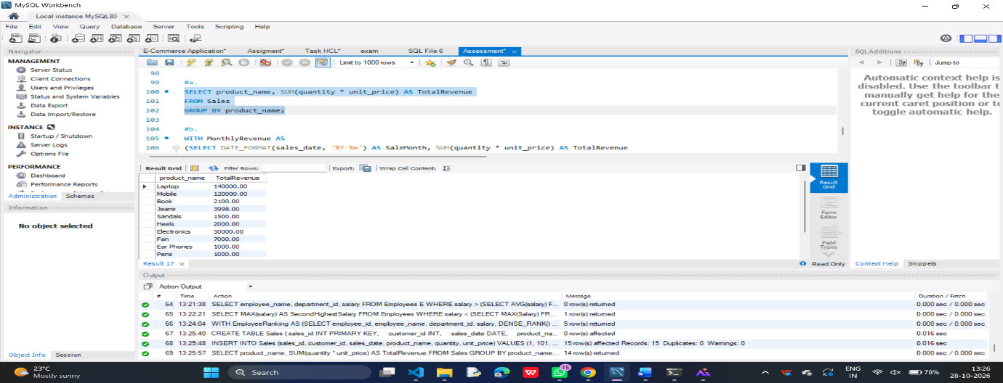

b)
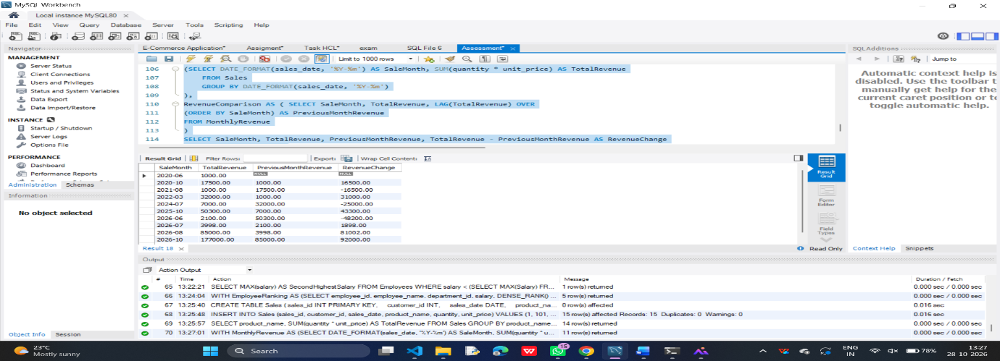
c)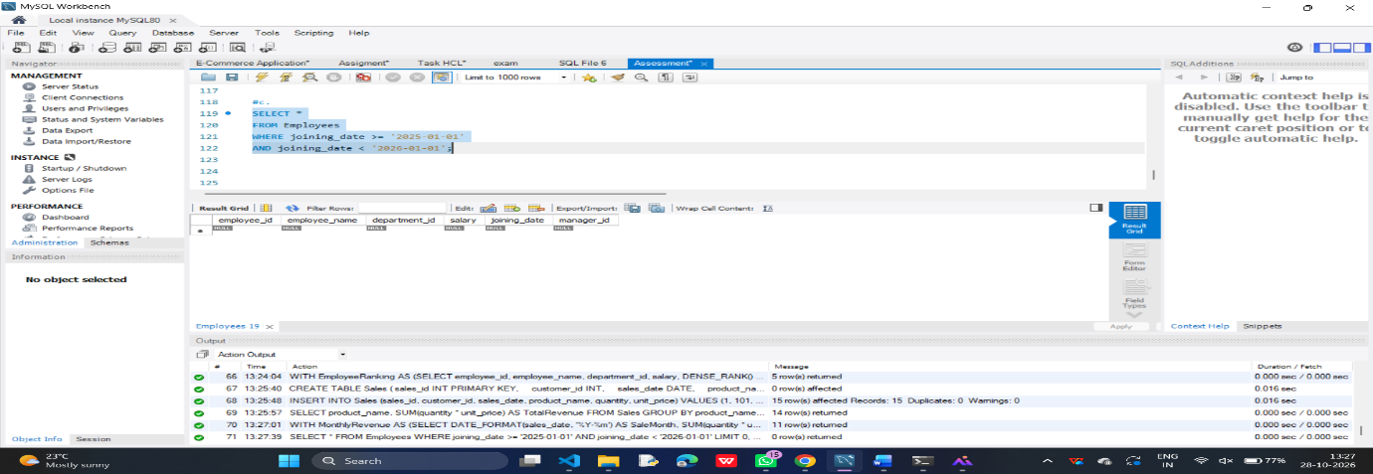

Question 3: SQL Troubleshooting (6 Marks)
a)An execution plan shows how a database executes an SQL query. It helps identify expensive operations such as full table scans, slow JOIN operations, and unnecessary row processing. It also shows whether indexes are being used. This helps improve query performance.
b) A composite index on DepartmentID and Salary improves query performance when searching employees using these two columns. It reduces the number of records the database needs to scan. The index can also support queries filtering only by DepartmentID. Column order is important because of the leftmost-prefix rule.
c) The GROUP BY clause groups customers having the same email address. The COUNT() function counts how many times each email appears. The HAVING clause filters the results and displays only email addresses occurring more than once.

SECTION B: LINUX || Maximum Marks: 15
Question 4: Log Analysis (5 Marks)
a)
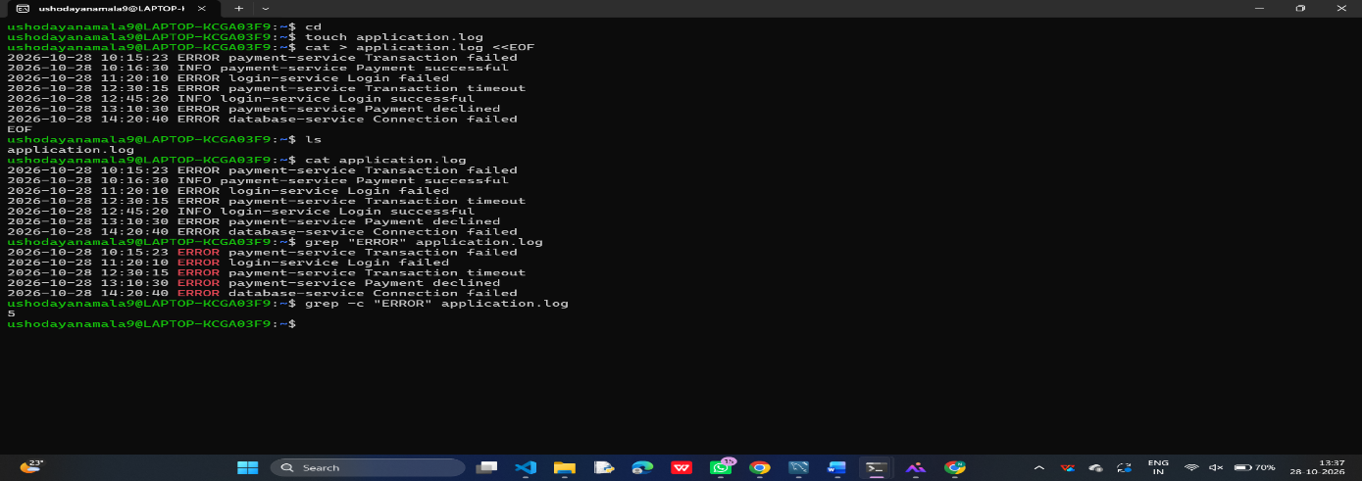
b)
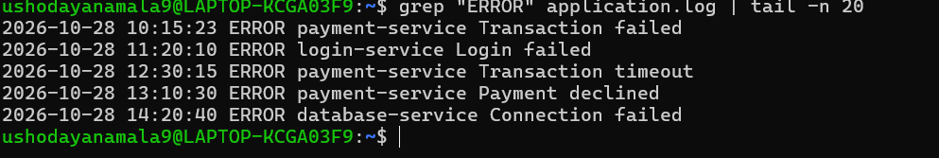
c)
d)
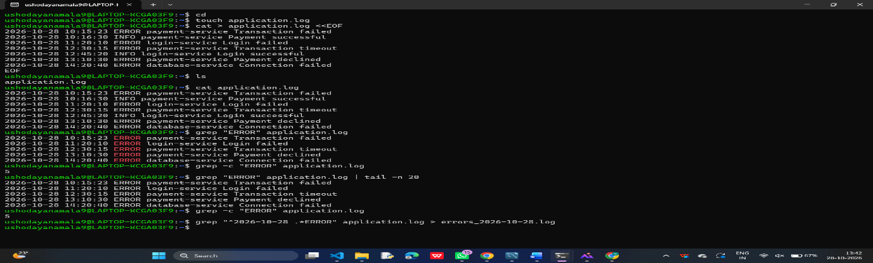

e)
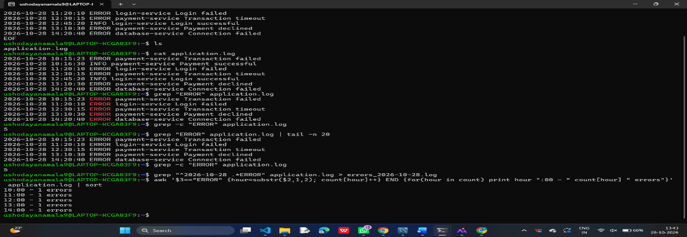

Question 5: Permissions and System Troubleshooting (5 Marks)
a)b)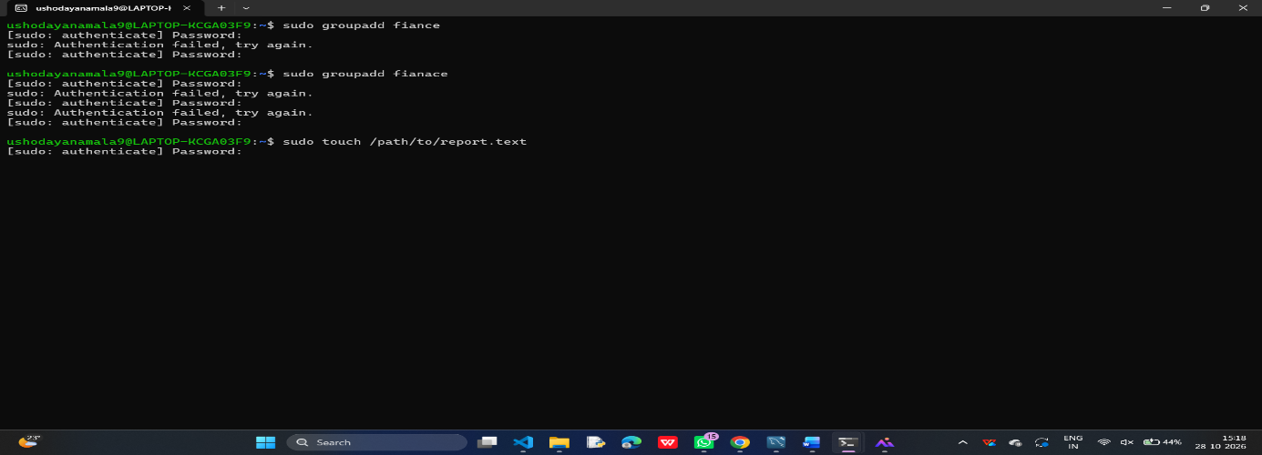
c)d)
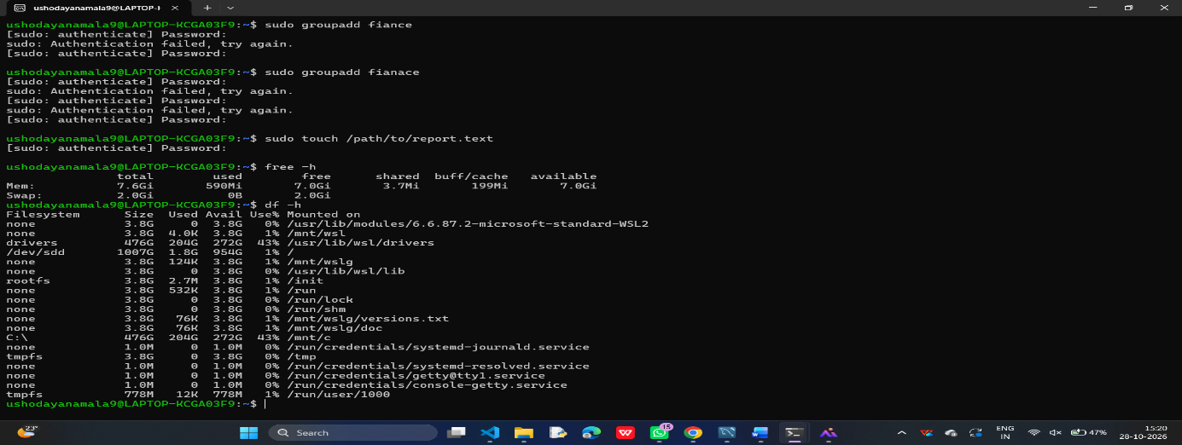

Question 6: Bash Scripting (5 Marks)
1)2)
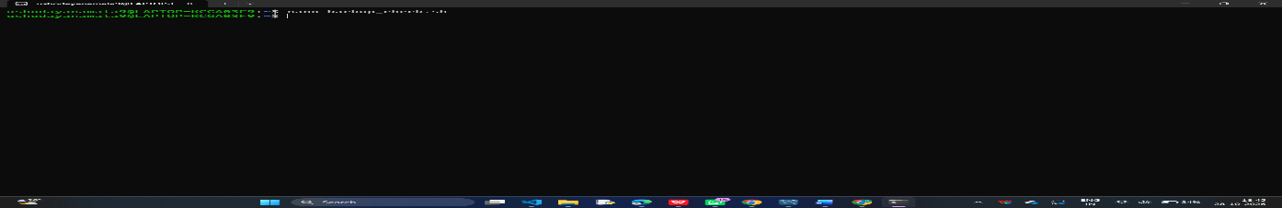

3)
Press Ctrl + O and Enter to save.
Press Ctrl + X to exit.
4)
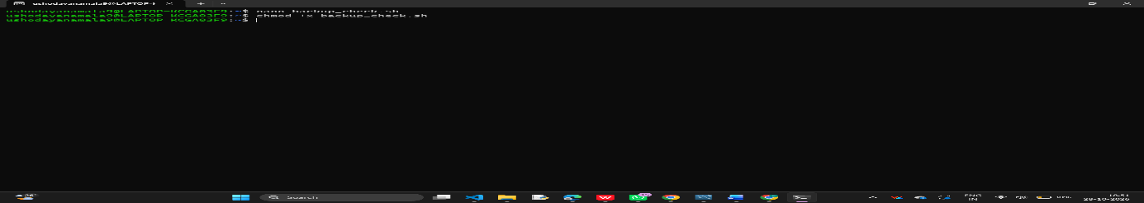
5)
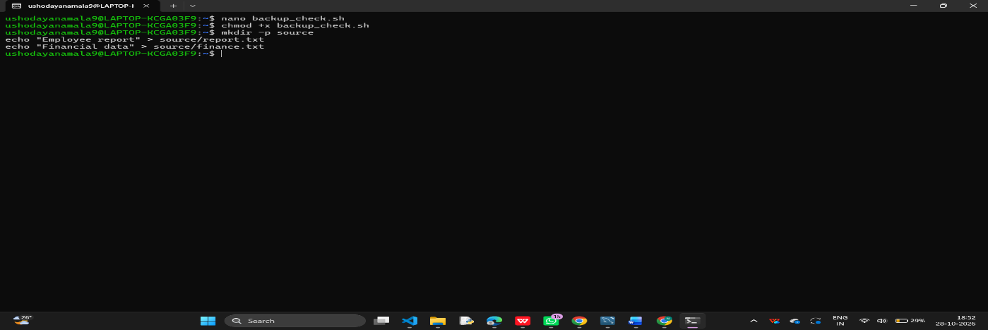

6)
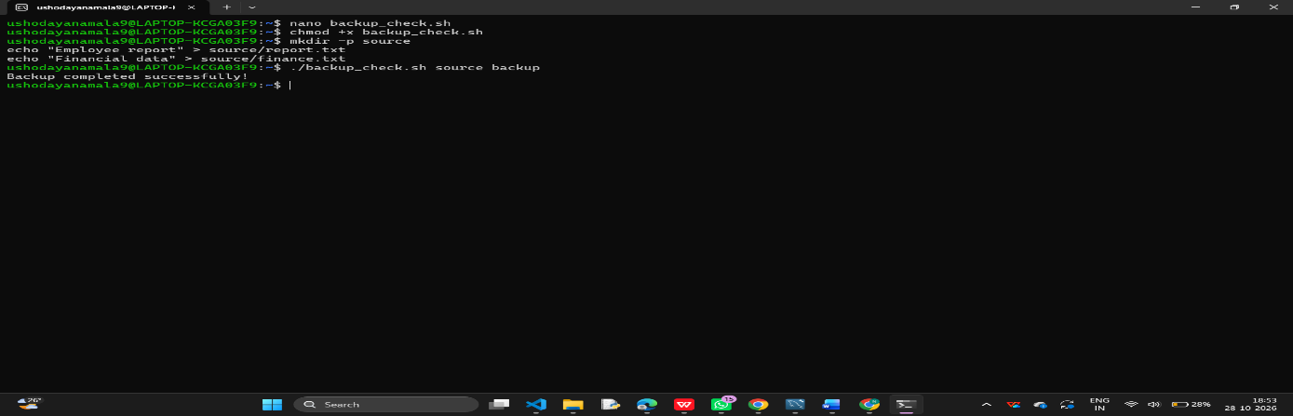
7)
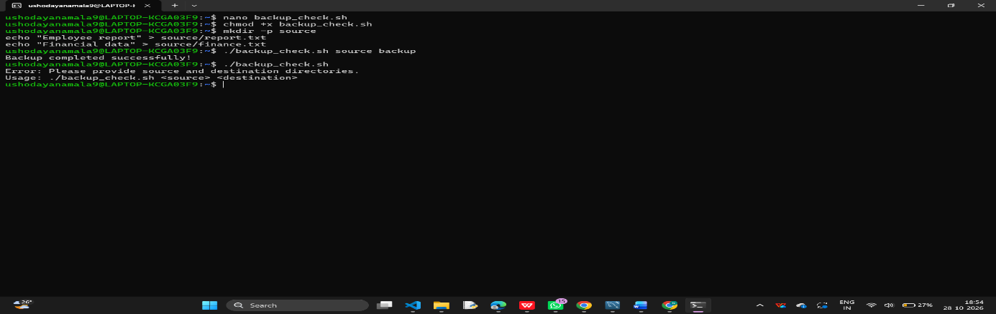

SECTION C: PYSPARK DATA ENGINEERING || Maximum Marks: 20 Question
7: PySpark DataFrame Operations (6 Marks)
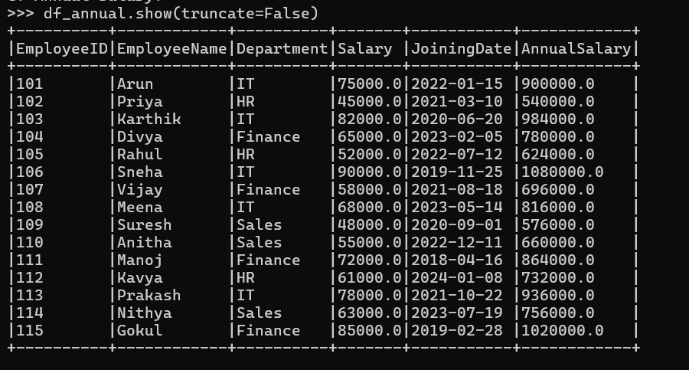
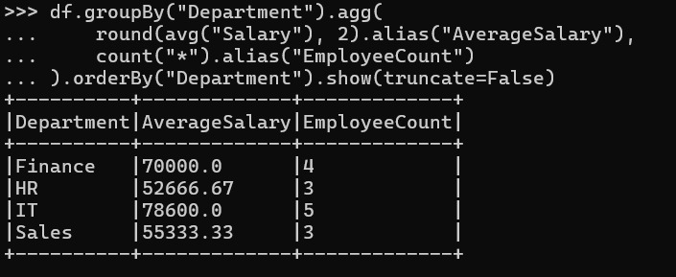
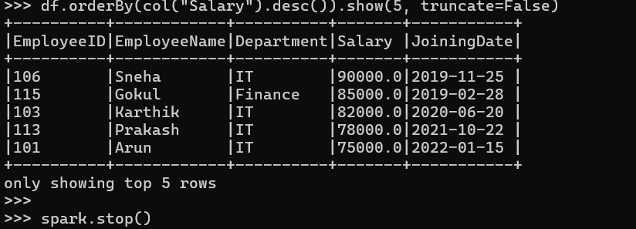

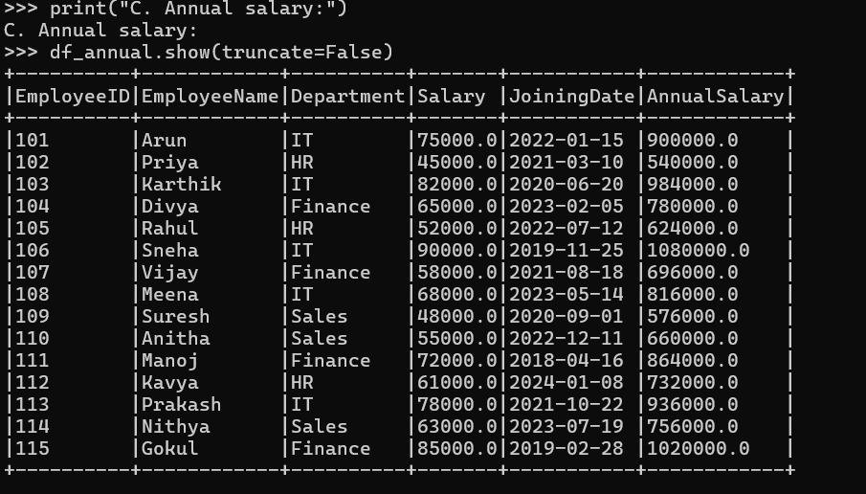
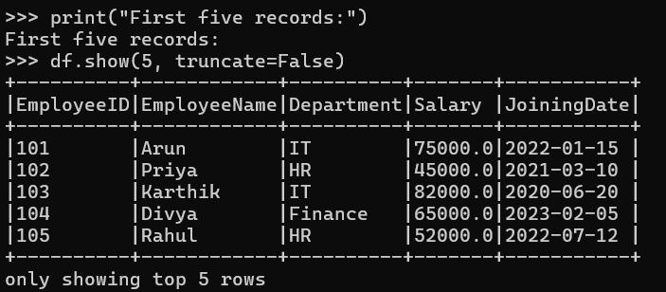
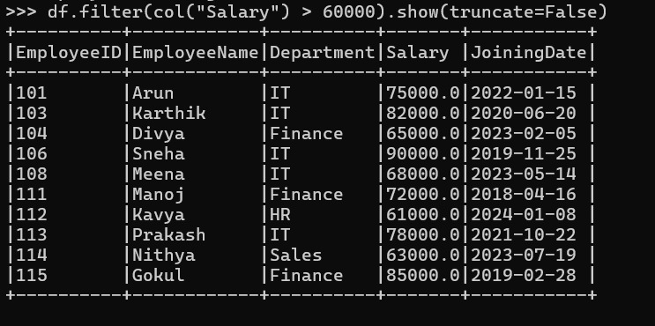

SECTION D: AWS CLOUD SERVICES || Maximum Marks: 15
Question 10: S3 and IAM Security (5 Marks)
a)
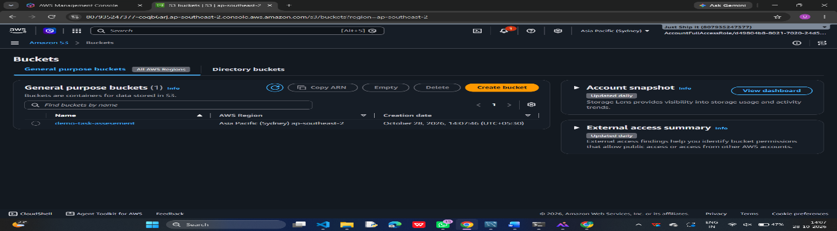
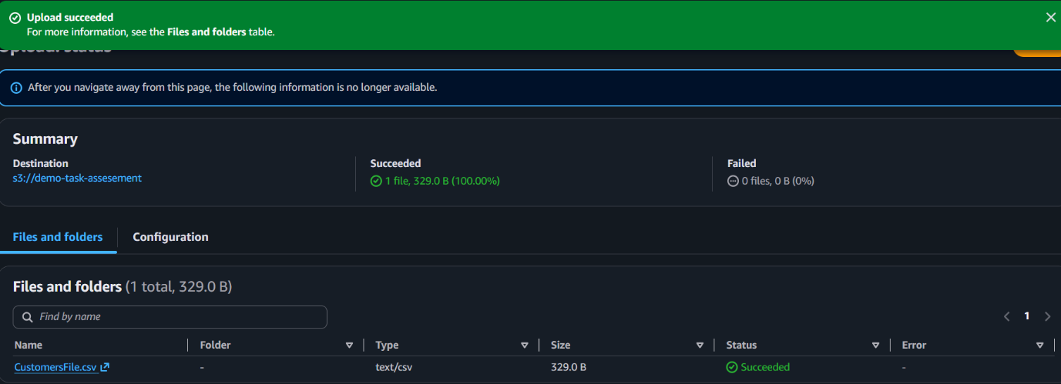
b)
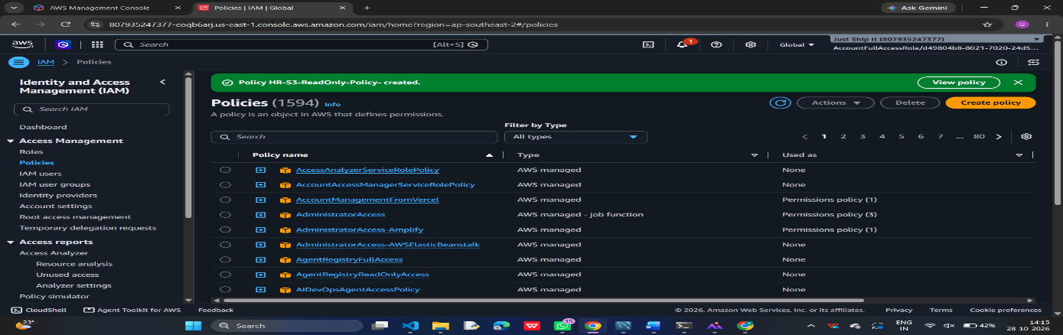
c)
We have to login using a authorized Iam user
Then open the S3 bucket
And then we have to open the uploaded file like customers.csv
The authorized user has to be able to download the file
Now try to login using the unauthorized Iam user without S3 read permissions
And try to access the same file
The result should be
For HR authorized user access is allowed and for the Unauthorized user the access should be denied
d)
Encryption at rest means converting stored data into an unreadable format using encryption.
Amazon S3 provides encryption to protect files stored in bucket

Question 11: EC2 Troubleshooting and CloudWatch (5 Marks)
A web application hosted on EC2 becomes slow, and users report connectivity problems.

a)
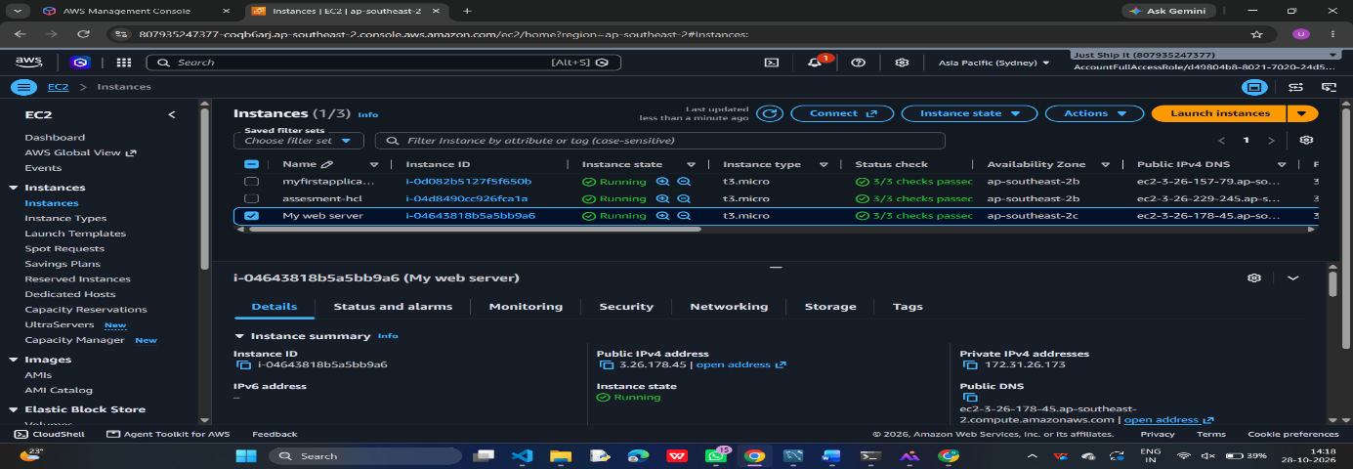
b)
Security Groups: Act as virtual firewalls for EC2 instances. They control incoming and outgoing traffic. If required ports like HTTP (80) or HTTPS (443) are blocked, users cannot access the application.
Route Tables: Control network traffic between subnets and other networks. If the route table does not have a proper route to an Internet Gateway, users may not be able to access a public application.
Proper security group rules and route table configurations are necessary for successful application connectivity.
c)
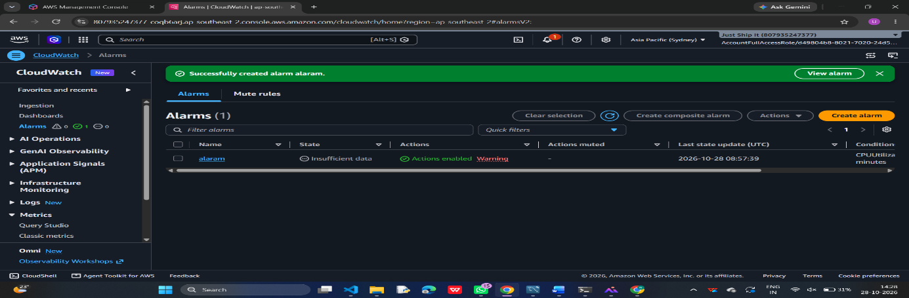
d)
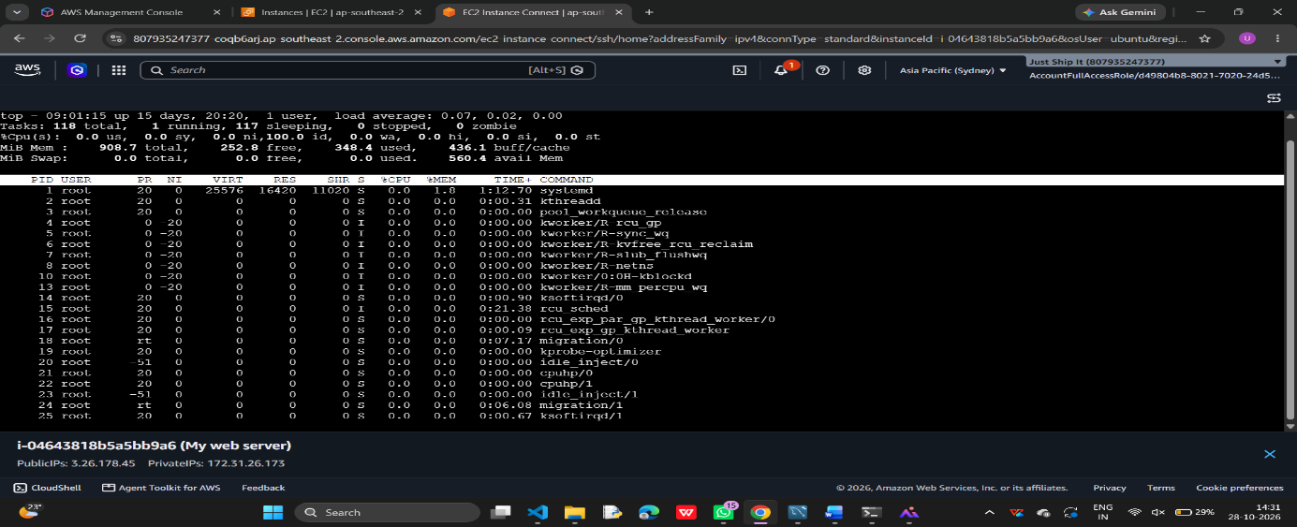

Question 12: Event-Driven Processing (5 Marks)
a)
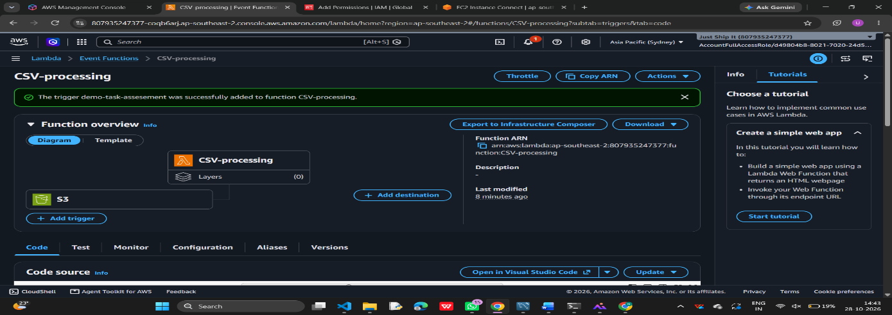
c) S3:GetObject – To read CSV files from the input bucket.
S3:PutObject – To write processed results into the output bucket.
d) We can use CloudWatch to check the processing logs and find errors if something goes wrong.
e) We can track already processed files to avoid duplicates and store the results in a separate S3 bucket to prevent repeated triggering.

SECTION E: AWS STEP FUNCTIONS || Maximum Marks: 15
Question 13: State Machine Design (7 Marks)
a) Validation State: AWS Lambda validates the input sales file.
Processing State: AWS Lambda transforms data and calculates total sales by product.
Storage State: Stores the processed results in Amazon S3.
Notification State: Amazon SNS sends a completion notification through email.
b) Choice state: The Choice state checks whether the file is valid. If valid, it continues processing; otherwise, it moves to the failure state.
c)Retry and Catch: Retry runs a failed task again if the error is temporary. Catch handles permanent errors and sends the workflow to a failure-handling state.
d) Invoking services: Step Functions can call Lambda functions or other supported AWS services to perform each processing step automatically.
e)Execution history: Execution history shows each state, its input and output, and any errors, helping us identify and fix failures.

Question 14: Step Functions Implementation (8 Marks)
a) Amazon States Language (ASL) is a JSON-based language used to define workflows in AWS Step Functions. It describes the tasks, sequence of execution, and error-handling methods.
b)Retry policy: The TransformData task retries temporary AWS service errors and timeouts up to three times, waiting two seconds initially and doubling the delay after each attempt.
c)Catch transition: If LoadResults fails, Catch sends the workflow to RecordFailure, which records the error before the workflow fails.
d)Passing data: Each task receives the previous task's output as its input by default. We can use ResultPath and OutputPath to control which data is passed.
e)Testing: Run one execution with valid input to check success, then test invalid input and simulated task failures to verify the failure, retry, and Catch paths.

SECTION F: MICROSOFT AZURE || Maximum Marks: 15
Question 15: Azure Data Lake Storage and Security (5 Marks)
a) Create an Azure Storage Account and enable Hierarchical Namespace for ADLS Gen2.
b)Create a filesystem or container and upload a sample CSV dataset.
c) Microsoft Entra ID identifies users, and Azure RBAC assigns permissions to access the data.
d)Test access using an unauthorized account and verify that access is denied.

Question 16: Azure VM Troubleshooting (5 Marks)
a)Check the VM's provisioning state and power state in the Azure Portal.
b)Incorrect Network Security Group rules may block SSH or RDP connections.
c)Incorrect subnet settings or route tables can prevent the VM from connecting to the network.
d)Use Azure Bastion to connect securely without exposing the VM's public IP. Also check boot diagnostics and network settings.

Question 17: Azure Data Integration (5 Marks)
a)Use Azure Data Factory to automate and manage data movement.
b) Create a pipeline to copy the CSV file from its source into Azure Data Lake Storage Gen2.
c) Organize files into date-based folders, such as year/month/day.
d)Use mapping data flows to handle malformed records and replace or remove missing values.
e) Monitor pipeline runs in Azure Data Factory and validate the row count to ensure all records are copied.

